**Assignment # 01**

**NAME : BASHARAT HUSSAN**

**ROLL NO: P17-6102**

**SECTION: A**

**Question # 01**

/* Name: BASHARAT HUSSAIN

Creation Date: 10/27/2018

Problem Description: This program calculate the power series expression. */

#include<iostream>

using namespace std;

void expx(int n);

int main(){

expx(4);

return 0;

}

void expx(int n){

float pwr=1;

float fac=1;

float sum=0.0;

int count=1;

int x;

cout<<"Enter the value of x"<<endl;

cin>>x;

for(int i=1;i<n;i++){

pwr=pwr*x;

fac=fac*i;

sum+=pwr/fac;

count++;

}

cout<<sum<<endl;

cout<<"Terms of serise: "<<count;

}

OUTPUT:  
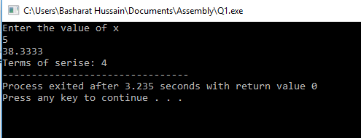

**Question # 02**

/* Name: BASHARAT HUSSAIN

Creation Date: 10/29/2018

Problem Description: This program calculates thes um of the Sin Cos And Tan serieses */

#include<iostream>

using namespace std;

float power(float base, float exponent){

float pwr=1;

for(int i=0; i<exponent; i++){

pwr=base*pwr;

}

return pwr;

}

float factorial(float number){

float fac=1;

for(int i=number; i>0; i--){

fac=fac*i;

}

return fac;

}

float sin(float x,float n){

float sum,div,app;

sum=x;

n=2*(n-1);

int i=1;

while(i<n){

if(i%2!=0){

app=power(x,i+2);

div=factorial(i+2);

sum-=app/div;

}

else{

app=power(x,i+2);

div=factorial(i+2);

sum+=app/div;

}

i+=2;

}

return sum;

}

float cos(float x,float n){

float sum,div,app;

sum=1;

n=2*(n-1);

int i=0;

while(i<n){

if(i%2!=0){

app=power(x,i+2);

div=factorial(i+2);

sum-=app/div;

}

else{

app=power(x,i+2);

div=factorial(i+2);

sum+=app/div;

}

i+=2;

}

return sum;

}

int main(){

cout<<sin(2,3)<<endl;

cout<<cos(2,3);

return 0;

}

OUTPUT:

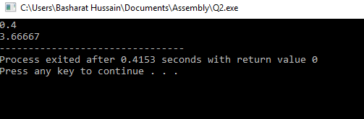

**Question # 03 (a) & (b)**

/* Name: BASHARAT HUSSAIN

Creation Date: 10/28/2018

Problem Description: This program returns third minimum value from array and returns fifth maximum value from array */

#include<iostream>

using namespace std;

int thirdMin(int array[], int n);

int fifthMax(int array[], int n);

int main()

{

int array[] = {1,2,3,4,5,6,7,8,9};

int n = sizeof(array) / sizeof(array[0]);

thirdMin(array, n);

fifthMax (array, n);

return 0;

}

int thirdMin(int array[], int n)

{

int Min = 1000;

for (int i = 0; i < n; i++)

{

if (array[i] < Min)

Min = array[2];

}

cout << "Third minimum value from Array is : = " << Min <<endl;

}

int fifthMax(int array[], int n)

{

int Max = 0;

for (int i = 0; i < n; i++)

{

if (array[i] > Max)

Max = array[4];

}

cout << "Third Maximum value from Array is : = " << Max <<endl;

}

OUTPUT:

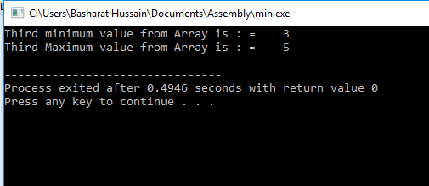

**Question # 04**

/* Name: BASHARAT HUSSAIN

Creation Date: 10/28/2018

Problem Description: This program Swap values such that a = b, b = c, c=d, d=e and e = a. */

#include<iostream>

using namespace std;

void rotate(int&a, int&b, int&c, int&d,int&e){

int temp1;

int temp2;

int temp3;

int temp4;

int temp5;

temp1=a;

a=b;

temp2=b;

b=c;

temp3=c;

c=d;

temp4=d;

d=e;

temp5=e;

e=temp1;

cout<<"a= " << a<<endl;

cout<<"b= " << b<<endl;

cout<<"c= " << c<<endl;

cout<<"d= " << d<<endl;

cout<<"e= " << e<<endl;

}

int main(){

int a,b,c,d,e;

cout<<"Enter the values of a: ";

cin>>a;

cout<<"Enter the values of b: ";

cin>>b;

cout<<"Enter the values of c: ";

cin>>c;

cout<<"Enter the values of d: ";

cin>>d;

cout<<"Enter the values of e: ";

cin>>e;

cout<<endl<<endl;

cout<<"The updated values of variables are: "<<endl;

rotate(a,b,c,d,e);

}

OUTPUT:

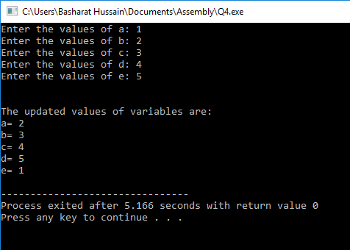

**Question # 05**

/* Name: BASHARAT HUSSAIN

Creation Date: 10/27/2018

Problem Description: This program displays the shape of DIAMOND on console. */

#include<iostream>

using namespace std;

int main()

{

cout<<"Enter size of Daimond: ";

int size;

cin>>size;

int z=1;

for ( int i=0; i<=size; i++)

{

for (int j=size; j>i; j--)

{

cout<<" ";

}

cout<<"*";

if ( i>0)

{

for ( int k=1; k<=z; k++)

{

cout<<" ";

}

z+=2;

cout<<"*";

}

cout<<endl;

}

z-=4;

for (int i=0; i<=size-1; i++)

{

for (int j=0; j<=i; j++)

{

cout<<" ";

}

cout<<"*";

for (int k=1; k<=z; k++)

{

cout<<" ";

}

z-=2;

if (i!=size-1)

{

cout<<"*" }

cout<<endl;

}

return 0;

} OUTPUT

